Due on: November 3, 2022

**Introduction to Microcomputers**

**Lab2**

The goal of this lab is to use the comparison instructions of PIC16F877A to implement some if statements.

**Assignment**

Consider the following division of the 2D plane based on the values of x and y variables:

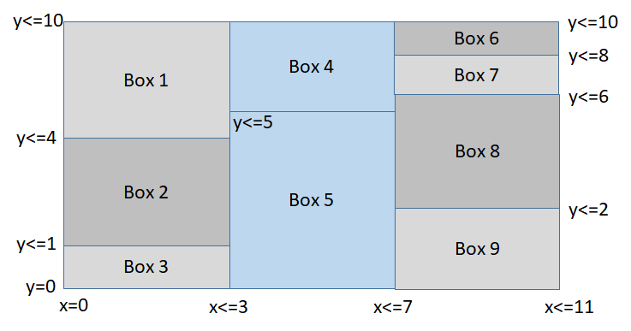

Given x and y values, we would like to know which box we are in. We can do that using a C code as given below:

|  |
| --- |
| int8_t x = 5;  int8_t y = 6;  uint8_t box;  if (x < 0 || x > 11 || y < 0 || y > 10) box = -1; // We do not fall inside a valid box  else if (x <= 3){  if (y <= 1) box = 3;  else if (y <= 4) box = 2;  else box = 1;  } else if (x <= 7){  if (y <= 5) box=5;  else box=4;  } else {  if (y<=2) box=9;  else if (y<=6) box=8;  else if (y<=8) box=7;  else box=6;  } //end-else  PORTD = box; // Display the box number on the LEDs |

In this lab you are asked to implement the above logic in PIC assembly code. Test your code thoroughly to make sure that it works for all cases. The TAs will test your code with some random x and y values. Your code must work correctly for you to get the full grade. **No partial credit will be given.**